Parallelogram Diagonals Theorem

Definition
# Source: AI Source: Provided by: [Data Path: Persons Table -> ID Column: 1, Name_En Column: Motasem Essam] -> From: [ChatGPT] on [7/25/2026]
The Parallelogram Diagonals Theorem states:
The diagonals of a parallelogram bisect each other.
In parallelogram $ABCD$, the diagonals $\overset{‾}{AC}$and $\overset{‾}{BD}$intersect at a point $O$.
Therefore:
$$\boxed{AO=OC}$$
and
$$\boxed{BO=OD}$$
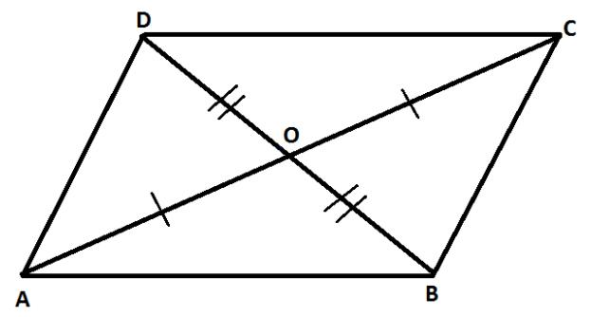
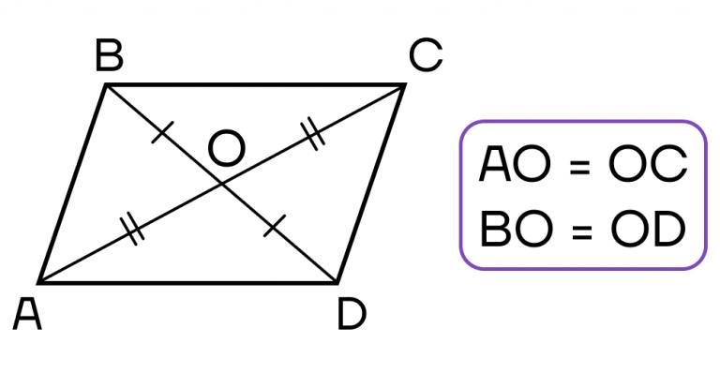
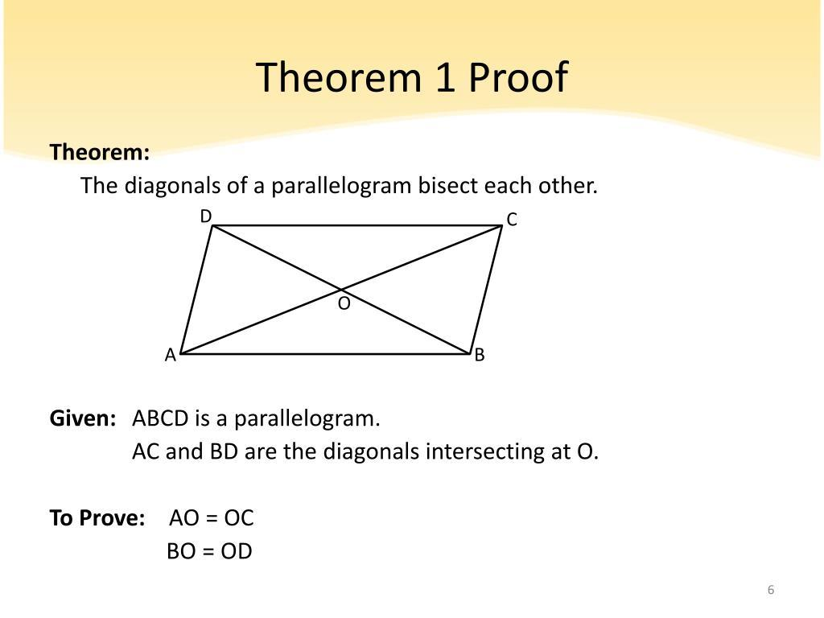
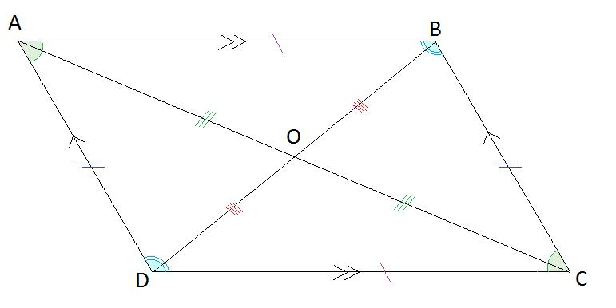

Fundamental Concept
# Source: AI Source: Provided by: [Data Path: Persons Table -> ID Column: 1, Name_En Column: Motasem Essam] -> From: [ChatGPT] on [7/25/2026]
A parallelogram has two diagonals:
$$\overset{‾}{AC}$$
and
$$\overset{‾}{BD}$$
They intersect at a single point $O$.
The intersection divides each diagonal into two equal segments:
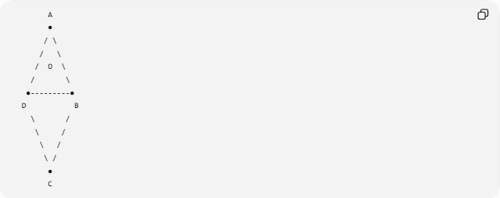
A
●
/ \
/ \
/ O \
/ \
●---------●
D B
\ /
\ /
\ /
\ /
●
C
Thus:
$$AO=OC$$
and
$$BO=OD$$

Mathematical Representation
# Source: AI Source: Provided by: [Data Path: Persons Table -> ID Column: 1, Name_En Column: Motasem Essam] -> From: [ChatGPT] on [7/25/2026]
For parallelogram $ABCD$, if:
$$AC∩BD=\left\{O\right\}$$
then:
$$\boxed{AO=OC} \\ \boxed{BO=OD}$$
Equivalently, $O$is the midpoint of both diagonals.
Therefore:
$$\boxed{O=midpoint⁡\left(AC\right)}$$
and
$$\boxed{O=midpoint⁡\left(BD\right)}$$

Proof
# Source: AI Source: Provided by: [Data Path: Persons Table -> ID Column: 1, Name_En Column: Motasem Essam] -> From: [ChatGPT] on [7/25/2026]
Consider parallelogram $ABCD$.
Since opposite sides are parallel:
$$AB∥CD$$
Draw diagonal $AC$.
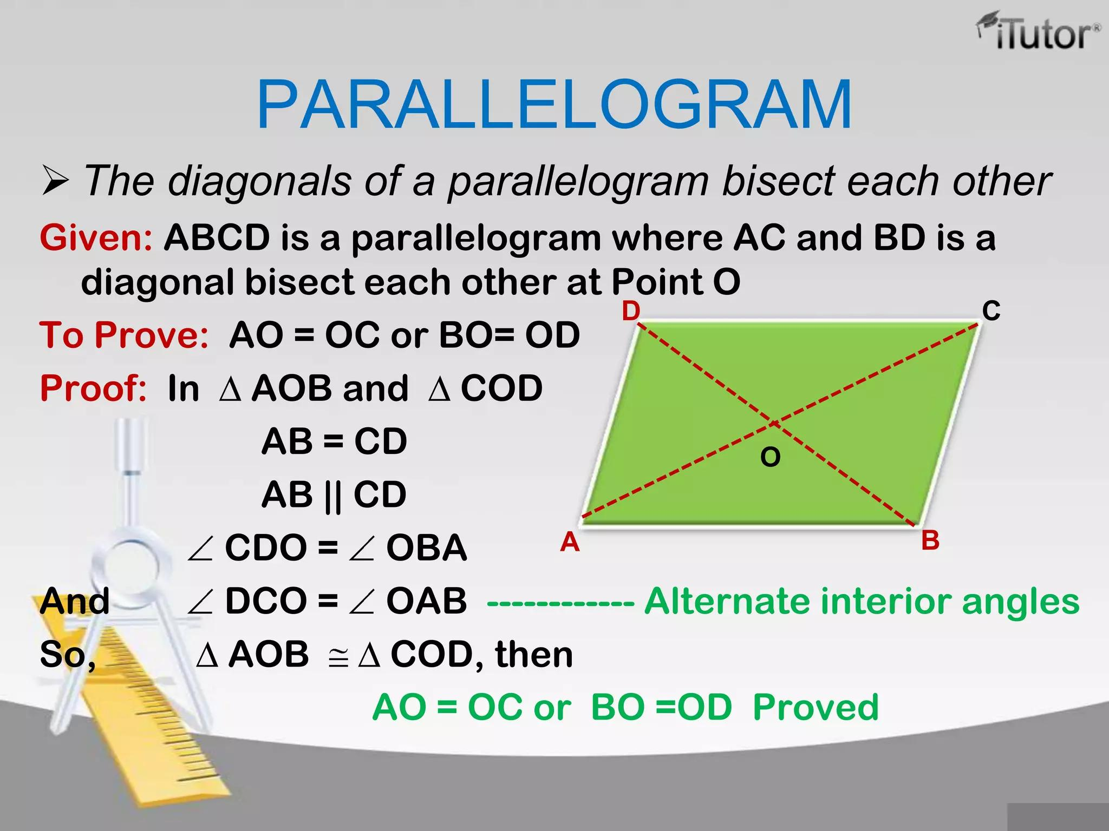
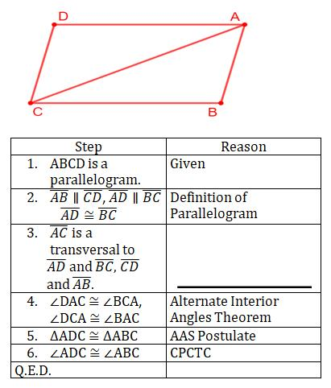
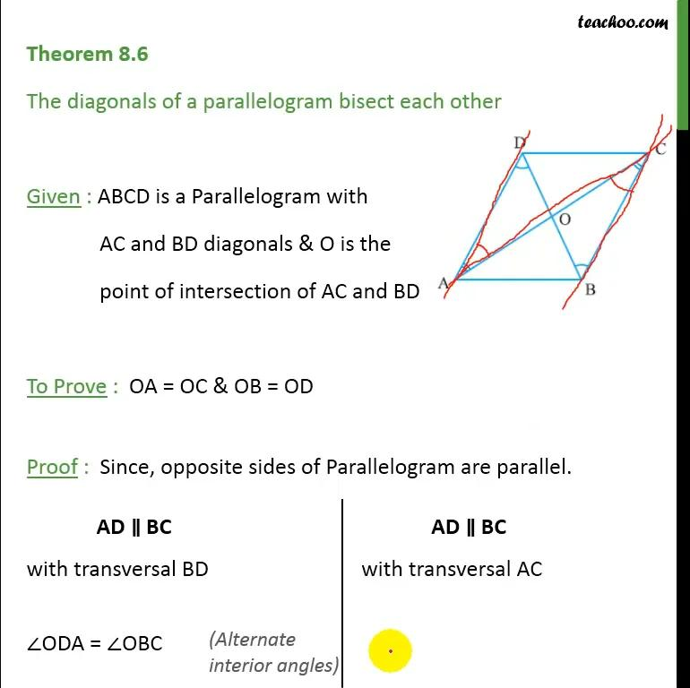
Let diagonals $AC$and $BD$intersect at $O$.
Consider:
$$△AOB$$
and
$$△COD$$
Because $AB∥CD$:
$$∠ABO=∠CDO$$
by alternate interior angles.
Also:
$$∠BAO=∠DCO$$
by alternate interior angles.
The angles at $O$are vertical angles:
$$∠AOB=∠COD$$
Therefore:
$$△AOB≅△COD$$
by ASA.
Corresponding sides are equal:
$$\boxed{AO=OC}$$
and:
$$\boxed{BO=OD}$$
Hence, the diagonals bisect each other.

Example 1
# Source: AI Source: Provided by: [Data Path: Persons Table -> ID Column: 1, Name_En Column: Motasem Essam] -> From: [ChatGPT] on [7/25/2026]
Suppose the diagonals intersect at $O$, and:
$$AO=7\text{ cm}$$
According to the theorem:
$$AO=OC$$
Therefore:
$$\boxed{OC=7\text{ cm}}$$
The entire diagonal is:
$$AC=AO+OC \\ AC=7+7 \\ \boxed{AC=14\text{ cm}}$$

Example 2
# Source: AI Source: Provided by: [Data Path: Persons Table -> ID Column: 1, Name_En Column: Motasem Essam] -> From: [ChatGPT] on [7/25/2026]
Suppose:
$$BO=12\text{ cm}$$
Then:
$$BO=OD$$
so:
$$\boxed{OD=12\text{ cm}}$$
Therefore:
$$BD=BO+OD \\ BD=12+12 \\ \boxed{BD=24\text{ cm}}$$

Example 3 — Algebraic Lengths
# Source: AI Source: Provided by: [Data Path: Persons Table -> ID Column: 1, Name_En Column: Motasem Essam] -> From: [ChatGPT] on [7/25/2026]
Suppose:
$$AO=3x+2$$
and:
$$OC=5x-10$$
Since the diagonals bisect each other:
$$AO=OC$$
Therefore:
$$3x+2=5x-10 \\ 12=2x \\ x=6$$
So:
$$AO=3\left(6\right)+2=20$$
and:
$$OC=5\left(6\right)-10=20$$
Thus:
$$\boxed{AO=OC=20}$$
and:
$$\boxed{AC=40}$$

Vector Interpretation
# Source: AI Source: Provided by: [Data Path: Persons Table -> ID Column: 1, Name_En Column: Motasem Essam] -> From: [ChatGPT] on [7/25/2026]
If the vertices have position vectors:
$$A,B,C,D$$
then the diagonals of a parallelogram have the same midpoint:
$$\boxed{\frac{A+C}{2}=\frac{B+D}{2}}$$
Therefore, the intersection point $O$is:
$$\boxed{O=\frac{A+C}{2}=\frac{B+D}{2}}$$
This is an important characterization of parallelograms in coordinate and vector geometry.

Coordinate Example
# Source: AI Source: Provided by: [Data Path: Persons Table -> ID Column: 1, Name_En Column: Motasem Essam] -> From: [ChatGPT] on [7/25/2026]
Consider:
$$A\left(1 , 1\right), B\left(7 , 2\right), C\left(10 , 6\right), D\left(4 , 5\right)$$
The midpoint of $AC$is:
$$M_{AC}=\left(\frac{1+10}{2} , \frac{1+6}{2}\right) \\ M_{AC}=\left(\frac{11}{2} , \frac{7}{2}\right)$$
The midpoint of $BD$is:
$$M_{BD}=\left(\frac{7+4}{2} , \frac{2+5}{2}\right) \\ M_{BD}=\left(\frac{11}{2} , \frac{7}{2}\right)$$
Both diagonals have the same midpoint:
$$\boxed{O=\left(\frac{11}{2} , \frac{7}{2}\right)}$$
Therefore, the diagonals bisect each other.

Important Distinction
# Source: AI Source: Provided by: [Data Path: Persons Table -> ID Column: 1, Name_En Column: Motasem Essam] -> From: [ChatGPT] on [7/25/2026]
The theorem says that the diagonals bisect each other.
It does not generally say that the diagonals are:
- equal in length,
- perpendicular,
- angle bisectors.
For a general parallelogram:
$$\boxed{AO=OC, BO=OD}$$
but generally:
$$AC≠BD$$
and:
$$AC⊥̸BD$$
Special Cases
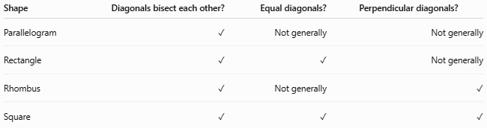
Shape | Diagonals bisect each other? | Equal diagonals? | Perpendicular diagonals?
Parallelogram | ✓ | Not generally | Not generally
Rectangle | ✓ | ✓ | Not generally
Rhombus | ✓ | Not generally | ✓
Square | ✓ | ✓ | ✓

Converse
# Source: AI Source: Provided by: [Data Path: Persons Table -> ID Column: 1, Name_En Column: Motasem Essam] -> From: [ChatGPT] on [7/25/2026]
The converse is also an important characterization:
If the diagonals of a quadrilateral bisect each other, then the quadrilateral is a parallelogram.
If diagonals $AC$and $BD$intersect at $O$and:
$$AO=OC$$
and
$$BO=OD$$
then:
$$\boxed{ABCD\text{ is a parallelogram}}$$
This provides one of the standard tests for proving that a quadrilateral is a parallelogram.

Key Points
# Source: AI Source: Provided by: [Data Path: Persons Table -> ID Column: 1, Name_En Column: Motasem Essam] -> From: [ChatGPT] on [7/25/2026]
- A parallelogram has two diagonals.
- The diagonals intersect at a common midpoint.
- Each diagonal is divided into two equal segments.
- If $O$is the intersection:
$$\boxed{AO=OC} \\ \boxed{BO=OD}$$
- The diagonals are not necessarily equal.
- The diagonals are not necessarily perpendicular.
- The common midpoint provides a coordinate/vector characterization of a parallelogram.
- The converse can be used to prove that a quadrilateral is a parallelogram.

Conclusion
# Source: AI Source: Provided by: [Data Path: Persons Table -> ID Column: 1, Name_En Column: Motasem Essam] -> From: [ChatGPT] on [7/25/2026]
The Parallelogram Diagonals Theorem establishes that:
$$\boxed{\text{The diagonals of a parallelogram bisect each other.}}$$
For parallelogram $ABCD$, with diagonals intersecting at $O$:
$$\boxed{AO=OC \text{and} BO=OD}$$
Thus, $O$is the midpoint of both diagonals.

